Web Development (Introduction) & WEDE5020
Website project proposal
Part 1 Section 1of 2:
Nonkululeko Sibiya
ST No. 10502108
Group 01
DNM0601
Diploma In Network Management
Due 31 July 2026
Lecturer: C. Nukeri

Table of Contents
Proposal 1 3
KreatedByKeora (Nail Artistry Studio) 3
1. The Organisation Overview 3
2. The Website Goals and objectives 3
3.The Current website 4
4. The Proposed website functionality and features. 4
5. The Design & User experience 5
6. Technical Requirements for the Website 7
7. The timeline and milestones 7
8. Budget 7
9.References 8
Proposal 2 9
1. Organisation overview 9
2. Website Goals and Objectives. 9
3. The current website analysis 10
4. Proposed Websites features and functionality. 10
5. The design and user experience 10
6. Technical Requirements 12
7. The Timeline and Milestones 12
8. The Budget 12
9. References 13

Proposal 1

KreatedByKeora (Nail Artistry Studio)

1. The Organisation Overview
Name: KreatedByKeora

- KreatedByKeora is a real, independently operated nail artistry studio/business that is based in Kibler Park, Johannesburg (South). The business owner is Keora; she is a qualified nail technician who has built a solid client base through social media platforms (TikTok and Instagram), she takes bookings and appointments through direct messages and “comment section”. The business does not have a website as of present day.
Figure 1KreatedByKeora Registered Logo


The Mission and Vision
Figure 2 Miss Keora's Work
- To create high-quality, creative, affordable nail artistry accessible to every client while growing into a recognised professional brand in Johannesburg South.
- To grow from a home/mobile-based nail studio into a recognized go-to nail destination.
- To hopefully partner with major brands for seasonal promotional events.

The Target Audience
- The business is targeted toward women aged 18 to 45 living in and around Kibler Park and the greater Johannesburg, actively looking for gel-x extensions, dramatic nail art and for those who follow beauty content on social media and book personal-care services via mobile.

2. The Website Goals and objectives
- Redirect enquiries and bookings from scattered social media platforms comment section/direct messages onto a single professional platform.
- Increase discoverability for clients searching online for her genre of nail art, not just client-based on followers.
- The website must showcase a well-curated portfolio that builds trust and credibility with new clients before their first visit/booking.
The KPIs
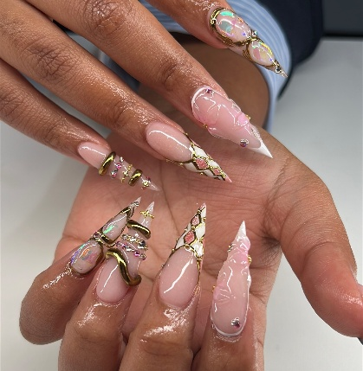
- A better booking channel; Transfer at least 40% of clients from direct messages to website form booking.
Figure 3 Miss Keora's Work
- An increase and consistent usage in website usage sessions.
- Better client retention, increased in number of enquiries from repeat clients shows that the site as supports rebooking and accommodative to new clients.

3.The Current website
KreatedByKeora does not have an existing website at present. Her TikTok and Instagram presence was reviewed, and the following has been concluded.
Strengths | Weaknesses
- The business has established a following on social media.  - There is a large library of nail-art content that is reusable on the site. | - There is no centralised price list.  - No formal booking systems for clients.  - There is a low visibility to non-followers (which supports the need for a simple, mobile website for clients).

4. The Proposed website functionality and features.

Homepage | - Either the business owner’s image or business logo.  - Simple, brief introduction.  - ‘Book Now’ button as a call to action for the clients.  - A navigation menu.
About Us | - Write a short story about Keora (the business owner), her journey into becoming a nail technician and her reasoning.  - Provide a business background and its challenges.  - Provide a business studio philosophy
Services provided | - Nail treatment with indicative pricing; Gel, acrylic, simple and dramatic nail art.
Enquiry | - Develop a booking form that captures preferred and available dates, service and possibly an external or internal image reference.
Contact details. | - Have a WhatsApp and a call number  - Link the social media app and websites.  - Link the studio address with google map for easier access.
Images | - All images will be taken from the business owner’ social media page.
Policies | - What is to be expected when booking, the deposit and late fee and last-minute cancellations.
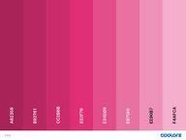

5. Design & User experience
Figure 4: The blush colour range for the website.
Colour scheme: A blush pink range and rose-gold on a charcoal base to present a modern, feminine premium display to clients.

Typography; An elegant serif for the headings that will be paired with a clean sans-serif for the body text.
Layout and design
- Mobile-first, it is a single-column layout that will be paired with a simple sticky navigation bar that will make it easy for clients to mainly browse the website via their phones.
- UX Considerations; Use large thumb-friendly button sizes, ensure that the images are fast loading and that when a client is actively using the website, ensuring that a repeated booking is called-to-action. The website should have a low-fidelity (visual sketch) wireframe for the homepage and services page that will be accompanied by the final submission/payment page.
Wireframe visual sketch
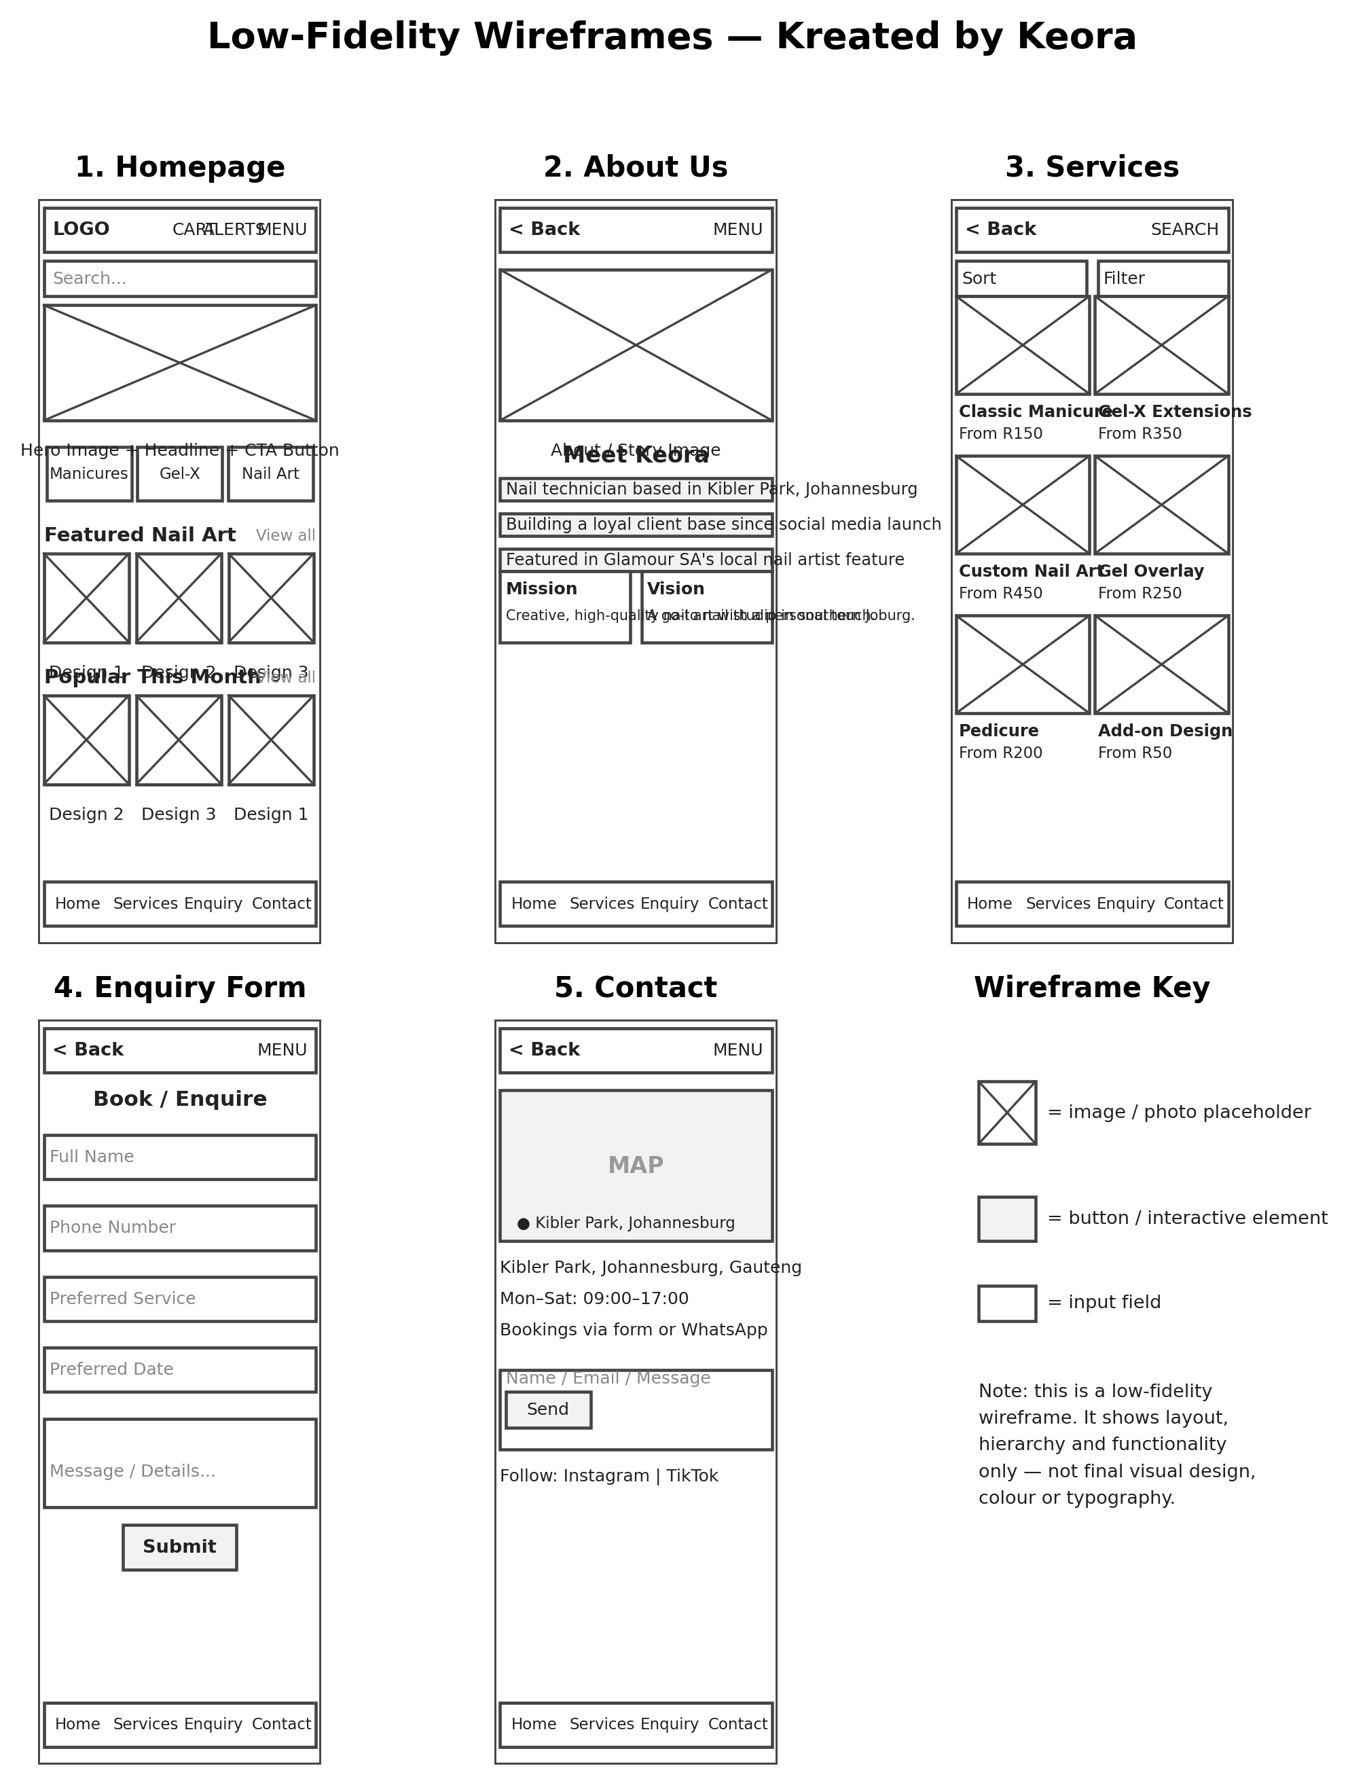
Figure 5Wireframe sketch created on https://wireframe.cc/

6. Technical Requirements for the Website
The website will need to be coded through HTML5, CSS3 & JavaScript. It will need a South African Domain (e.g. kreatedbykeeora.co.za). An affordable local shared host that must be used, that will have sufficient static for the smack business site.

7. The timeline and milestones
Dates | - Context
24 July 2026 to 31 July 2026 | - Research and planning.  - Creating the sitemap, wireframes, content/images collections
3 August 2026 to 14 August 2026 | - Create the HTML website using VS Code & GitHub
17 August 2026 to 28 August 2026 | - Start Part 2: Building the homepage and add the ‘About Us’ section, setting up files and folder structure.
31 August 2026 to 11 September 2026 | - Building the service and enquiry pages &  - Building the contact page and test the website navigation and links.  - Add stylising and design colours to the website
14 September 2026 to 18 September 2026 | - Proof -read and check the website. Test the links, loading times and everything else for the website.  - Submit Part 2
21 September 2026 to 02 October 2026 | - Review Part 1 and Part 2 and make improvements where necessary.  - Fixing errors and reviewing comments.
06 October 2026 to 23 October 2026 | - Part 3, Add JavaScript to the code.
27 October 2026 to 6 November 2026 | - Reviewing all additions.  - Fixing bugs
6 November 2026 – 20 November 2026 | - Proof -read and check the website. Test the links, loading times and everything else for the website.

8. Budget
The budget is approximate and not to a fixed scale.
Context | Approximate Cost (per year)
.co .za domain registration(once-off) and renewal (annual) | R150 – R250 (once off)  R100 – R200 (annually)
Research and planning | R1000 (once-off)
Web Development and design (Approximately 5-7 pages) | R4000 – R7000
Shared hosting (plus the SQL certification) | R900 to R1600
The images are taken from by the owner on her own personal device and edited using Cap Cut(free). | R0
Testing and maintenance | R300 to R1000
Total | R2450 – R10 050

9.References
Glamour South Africa, 2025. Nailed it: 9 local nail artists who are changing the game. [online] Available at: [Accessed 27 July 2026].
KreatedByKeora, [s.a.]. TikTok profile. [TikTok] Available at: [Accessed 27 July 2026].
All images are taken from KreatedByKeora main business account from Instagram < https://www.instagram.com/kreatedbykeora/ > [Accessed: 28 July 2026]

Proposal 2

AgriGrow Fertilisers & Distribution (Pty) Ltd

1. Organisation overview
Name: AgriGrow Fertilisers & Distribution (Pty) Ltd.
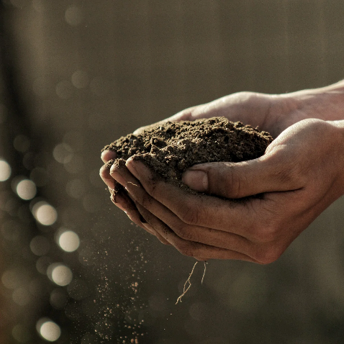
- AgriGrow is a fictional, family-owned fertiliser retail and distribution business that is based in Bothaville, in the province of Free State. The Free State is one of South Africa’s largest maize and grain-producing regions.
- AgriGrow was founded in 2015, it supplies granular, liquid, and organic fertilisers, soil conditioners and agri-inputs to South African commercial farmers, smallholder and co-operatives across the Free State province.

Mission & Vision
- The business aims to improve soil health and crop yields for the Free State farmers through reliable, well-priced products and dependable delivery, resulting in AgriGrow becoming the region’s most trusted and independent agri-input distributor.

Target Audience
- Commercial grain and maize farmers, smallholder and emerging farmers, agricultural co-operatives, and landscaping retailers across the Free State province and the neighbouring provinces.

2. Website Goals and Objectives.
- It is a qualified business-to-business lead product with enquires and quote requests.
- It provides an ‘always-available’ digital product catalogue and application guidance/instructions for use, reducing repetitive phone enquiries.
- It builds the brand credibility beyond the current word-of-mouth and in-store customer base.

The KPIs
- Content engagement: the number of spec sheet per month will indicate genuine buying interests.
- Increase in the month-to-month visits and purchases.
- Query deflection; there to be a reduction in phone/walk in-in product queries at both depot, which will free the business staff for sales and dispatch.

3. The current website analysis
AgriGrow does not have an existing website. The Free State agriculture supply is strong and competitive as the major businesses are solid and have a loyal customer base throughout the country. Most of the competitors offer static PDF price list that can be downloaded from their websites, but there are no interactive enquiry tools, delivery-area in information/good mobile usability. AgriGrow can use its competitors’ weaknesses to its advantageous for the website.

4. Proposed Websites features and functionality.
Homepage | A logo hero image, with a brief introduction and a call-to-action button (e.g. click to order).  Navigation Menu
About us | Add the company history, with the mission and vision for the business.  Add the sales and agronomy team
Products | Categorise the fertilisers range with valid downloadable spec sheets.
Enquiry | Have a product/quote enquiry form, plus a reseller-partnerships enquiry option.
Contact | Have two depot locations that are embedded with a map (e.g. Bothaville and Bloemfontein).

5. The design and user experience
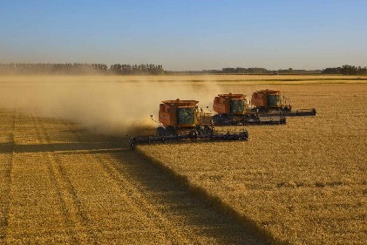
Colour Scheme
Earthly green tones, with wheat gold and warm brown tones, this will reflect the agriculture and growth.
Typography
A strong sans-serif for the headings that will be paired with a simple sans-serif body for scanning the technical information
The layout and design
The products will be displayed on a grid-based catalogue with category filtering, with a desktop-first view because it may have Business to business (B2B) customers who will be browsing from an office computer.

UX considerations; There will be a “Request a Quote” button and simple navigation so that customers can find product pricing quickly. It will also have a low-fidelity wireframe for the homepage.

Wireframe visual sketch

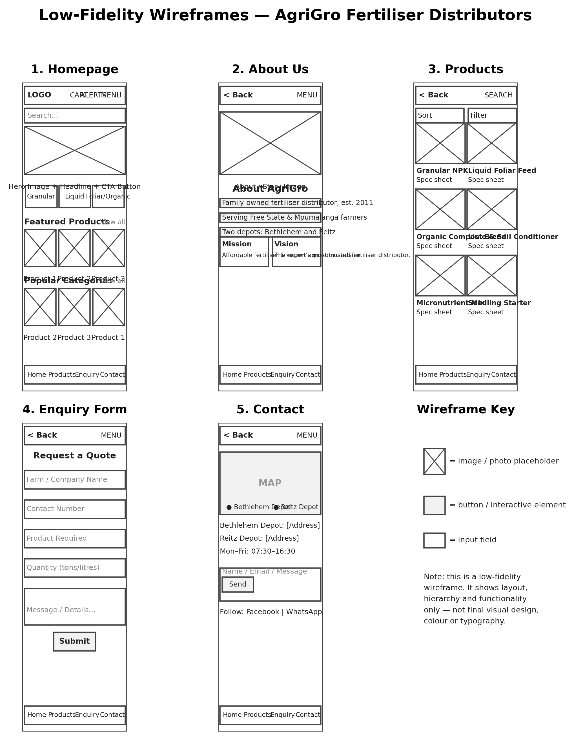
Figure 6Wireframe sketch created on https://wireframe.cc/

6. Technical Requirements
The website will use semantic HTML5, CSS, JavaScript. A “. co.za” domain (e.g. afrigrowfertiliser.co.za) will be registered, and it will be hosted on a business-grade plan that will be chosen for reliable uptime since it is a business-to-business enquiries.

7. The Timeline and Milestones

Dates | - Context
24 July 2026 to 31 July 2026 | - Research and planning.  - Creating the sitemap, wireframes, content\images collections
3 August 2026 to 14 August 2026 | - Create the HTML website using VS Code & GitHub
17 August 2026 to 28 August 2026 | - Start Part 2: Building the homepage and add the ‘About Us’ section, setting up files and folder structure.
31 August 2026 to 11 September 2026 | - Building the service and enquiry pages &  - Building the contact page and test the website navigation and links.  - Add stylising and design colours to the website
14 September 2026 to 18 September 2026 | - Proof -read and check the website. Test the links, loading times and everything else for the website.  - Submit Part 2
21 September 2026 to 02 October 2026 | - Review Part 1 and Part 2 and make improvements where necessary.  - Fixing error and reviewing comments.
06 October 2026 to 23 October 2026 | - Part 3, Add JavaScript to the code.
27 October 2026 to 6 November 2026 | - Reviewing all additions.  - Fixing bugs
6 November 2026 – 20 November 2026 | - Proof -read and check the website. Test the links, loading times and everything else for the website.

8. The Budget

Context / | Approximate Cost (per year)
.co .za domain registration(once-off) and renewal (annual) | R150 – R250 (once off)  R100 – R200 (annually)
Research and planning | R1000 - R2000 (once-off)
Web development and design | R8000 - R15000 (once off)
Domain Registration | R150 - R250
Business grade hosting | R1200 - R2000
Product photography and spec design | R2000 – R4000
Maintenance and content updates | R6000 -R9600
Total | R17 700 – R51 050

9. References

Department of Agriculture, Land Reform and Rural Development, 2022. *Maize production*. [pdf] Pretoria: Department of Agriculture, Land Reform and Rural Development. Available at: < https://www.nda.gov.za/phocadownloadpap/Brochures_and_Production_Guidelines/Maize%20brochure%20updated%20Nov%202022.pdf > [Accessed 27 July 2026].
Fertilizers, Farm Feeds, Seeds and Remedies Act 36 of 1947*. Pretoria: Government Printer. Available at: < https://www.gov.za/documents/fertilizers-farm-feeds-seeds-and-remedies-act-28-may-2015-1101 > [Accessed 27 July 2026].
Kriel, G., [s.a.]. Maize cultivation. [online] Available at: < https://southafrica.co.za/maize-cultivation.html > [Accessed 27 July 2026].
Sihlobo, W. and Kapuya, T., 2015. Grain market-overview. [online] Available at: < https://www.grainsa.co.za/grain-market-overview-4 > [Accessed 27 July 2026].
Vanlauwe, B., Amede, T., Bationo, A., Bindraban, P., Breman, H., Cardinael, R., Couedel, A., Chivenge, P., Corbeels, M., Dobermann, A., Falconnier, G., Fatunbi, W., Giller, K., Harawa, R., Kamau, M., Merckx, R., Palm, C., Powlson, D., Rusinamhodzi, L., Six, J., Singh, U., Stewart, Z., van Ittersum, M., Witt, C., Zingore, S. and Groot, R., 2023. *Fertilizer and soil health in Africa: The role of fertilizer in building soil health to sustain farming and address climate change*. [pdf] Muscle Shoals: International Fertilizer Development Center. Available at: < https://sia.faraafrica.org/wp-content/uploads/2025/03/Fertilizer-and-Soil-Health-in-Africa-.pdf > [Accessed 27 July 2026].
Vodacom, [s.a.]. Deal details. [online] Available at: < https://www.vodacom.co.za/shopping/deal-details-page/dv6g50daax > [Accessed 27 July 2026].
Github link:
https://github.com/Nkuwed/WEDE-kbk-main.git

